Option 1:
Super Slim, Super Selfie: The HUAWEI nova 12 Series Redefining Selfie Cameras and Style
Option 2:
HUAWEI nova 12 Series Launches with Ultraslim Design, Powerful Selfie Cameras
From Star Orbit Ring to 66W charging, nova 12 Series caters to the style-savvy

Huawei has recently announced a new line-up of the flagship HUAWEI nova 12 Series, which breaks ground with new selfie innovations and focuses on packing high-performance within slim yet stylish designs. Designed for the fashion-forward and tech-savvy, the nova 12 Series carries the hallmarks of the nova Series — ultra-thin design, shimmering Star Orbit Ring, and vibrant colours. Beyond the looks, Huawei’s newest flagships take bold leaps forward with cutting-edge camera innovations, ultra-fast charging, and EMUI 14.
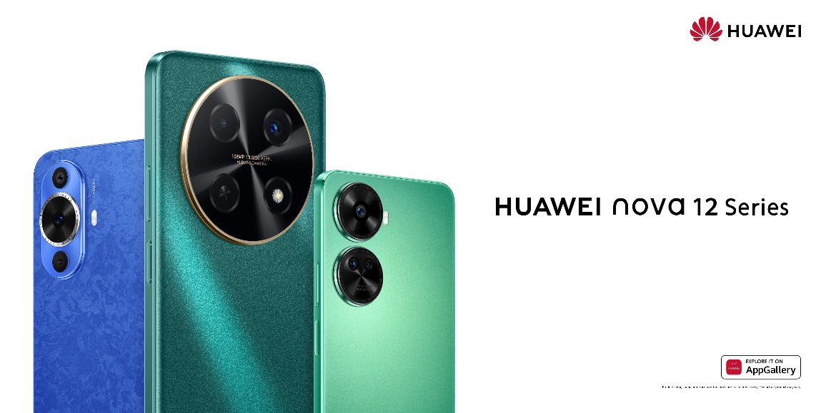

Ultra Slim, Ultra Stylish: The HUAWEI nova 12 Series
The nova series has always been driven by a philosophy of fusing design and technology. The HUAWEI nova 12 Series continues this ethos with a sleek and stylish design without compromising on performance and packing features to reflect the free-spirited, confident attitudes of its young users.

Leading the way, the HUAWEI nova 12s boasts a lightweight, razor-thin profile enhanced by the Extreme R Angle design. Both the HUAWEI nova 12s and 12 SE inherit the iconic and dazzling Star Orbit Ring design of nova series smartphones, while the HUAWEI nova 12i takes it a step further with the Super Star Orbit Ring. Inspired by the cosmic order and harmony of the universe, the Star Orbit Ring and Super Star Orbit Ring designs boast a celestial glow — a star-like brilliance it catches light. The nova 12 series comes in a range of eye-catching colours; from the HUAWEI nova 12s’ petal-patterned Blue to the emerald Green of the HUAWEI nova 12i, each colourway distinctively represents the passionate personalities and confident styles of the new generation.

A New Frontier for Selfie Camera Innovation
In today's social media-driven era, front cameras often steal the spotlight. Staying ahead of the trends, the HUAWEI nova 12 Series pushes the boundaries of selfie technology, letting users turn themselves into nova stars. Again, the one that takes the crown is the HUAWEI nova 12s which features a 60MP Ultra-Wide Selfie Camera, offering one of the highest resolution front cameras among smartphones at this price range. Thanks to the 100° ultra-wide angle, users will be able to capture larger group photos and vast backdrops of mountainous scenery or sprawling cityscapes. Complementing its stellar selfie capabilities, the nova 12s offers a versatile rear camera system – a 50MP Ultra Vision main Camera and 8MP Wide Angle Macro Camera offering countless ways to capture your shots.

The HUAWEI nova 12 SE and nova 12i also bring high-resolution magic to the cameras. They both come with a 108MP main camera with a large F1.9 aperture for excellent low-light performance. The HUAWEI nova 12 SE takes it a step further with a 32MP High-Res Front Camera System.

66W HUAWEI SuperCharge Turbo 2.0
Yet another strong point of the nova 12 Series is its battery life and charging capabilities. The HUAWEI nova 12s houses a large 4500 mAh battery and supports 66W HUAWEI SuperCharge Turbo 2.0 for a quick power-up when needed.

In the case of the HUAWEI nova 12i, it boasts the series' largest battery capacity at 5000mAh, coupled with 40W HUAWEI SuperCharge Turbo. This combination minimises the hassle of frequent charging and sustains the needs of power users.

The HUAWEI nova 12 SE comes with a 4500mAh battery and the 66W HUAWEI SuperCharge Turbo 2.0 as the nova 12s, delivering a full charge in just 32 minutes.

Revolutionising User Experience
The nova 12 Series is the first smartphone to launch the new EMUI 14. It steps up security, personalisation and efficiency, giving users a vastly superior and fuss-free interface and fun customisations to engage with. EMUI 14 brings exciting features like Live View, providing real-time glimpses of app activity right from your lock screen, and customizable Lock Screen Themes that let you express your unique style.

EMUI 14 takes privacy seriously, putting users in complete control of app permissions and access to their data. The simplified interface makes managing these settings easier than ever, with intuitive toggle buttons for quick adjustments.

